**Question 1:**

Find out the mail servers of the following domain :

Ibm.com

Wipro.com

**ANS:**

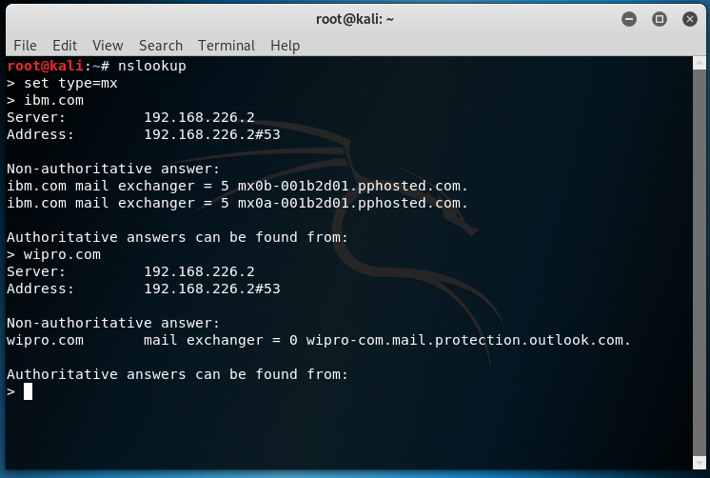

**Question 3:**

Scan and find out port numbers open 203.163.246.23

**ANS**

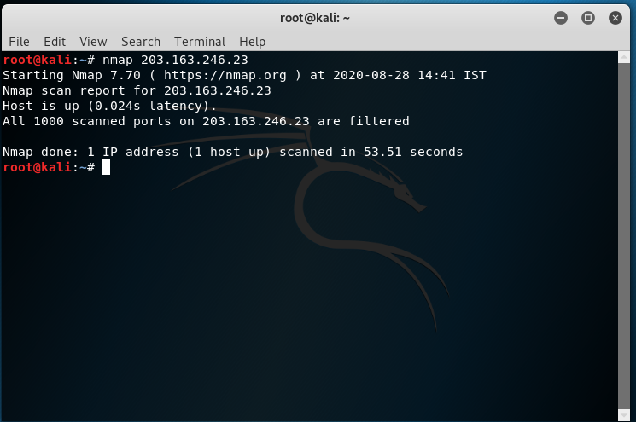

**Question 4:**

Install nessus in a VM and scan your laptop/desktop for CVE.

**ANS: As I don’t have business email id I can’t do it. I will try it later.**